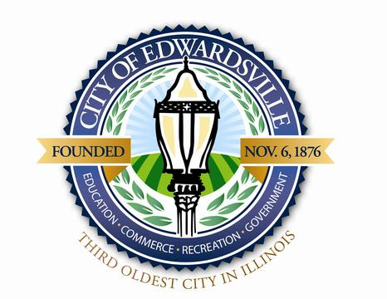

Meeting Date: Thursday, February 16th, 2023
Meeting Time: 6:00 P.M.
Meeting Location: City Hall-118 Hillsboro Avenue Edwardsville, IL 62025

COOL CITIES COMMITTEE AGENDA

Committee Members

Cara Lytle
Stephanie Malench
Kristen Pauli
Sherrill Wible
Rachel Tompkins, Chair
Brigham Dimick
Jamie Henderson
Michael Katich
Tom Kinsella

1. Call to Order
2. Roll Call
3. Approval of Minutes from the January 19th, 2022 Cool Cities Committee meeting
4. Citizens wishing to address the Board
A. Mary Vandevord – Heartlands Conservancy
B. Sarah Cundiff – Tree and Beautification Commission
C. Mary Grose – Good Dirt Composting/Community Garden
5. Announcements
A. Open Meetings Act
6. Old Business
A. Republic Services - Recycling at Public Events
B. Parking Ordinance
C. Green Cities Challenge
7. New Business
8. Adjournment

Next Cool Cities Committee Meeting: March 16 at 6:00 p.m. at City Hall, 118 Hillsboro Avenue

If prospective attendees require an interpreter or other access accommodation, please contact the Edwardsville City Clerk’s office at 618-692-7500 no later than 48 hours prior to the commencement of the meeting to arrange the accommodations

